AutoEmail Full Installation Tests
Tester: Tony Tasker
Date: 16th November 2016
Time: 16:45
PC/Server: TonyTasker-PC
Database: CABS_TEST (Copy of SHU DB)
Works Summary: N/A
Works Order: N/A
Task: N/A
Notes: These tests were performed using Microsoft SQL Server Management Studio. Output to the Results and Messages Output Windows are used to determine the success of the tests. Also the receipt of emails.

Pre-Test Setup
No | Task | Tester | Pass | Notes
1 | In X CABS Config, Section CABS_AUTO_EMAIL_FUNCS if WIPWindow is set then  WIPWindow=0 and  DebugFlag=1  In section CABS_AUTO_EMAIL_FUNCS_Trigger  Set DebugFlag=1 | TT
2 | In X CABS Config, Section AEFPBK ensure that the Enabled Key has the value:  Enabled=I:1;U:0;D:0 | TT

Post-Test Setup
No | Task | Tester | Pass | Notes
1 | Reverse any Config Changes in X CABS Config | TT

Tests

Provisional Booking Email - AEFPBK
No | Test | Tester | Pass | Notes
1 | In CABS locate a function to test with:  SELECT * FROM FUNC_FIL WHERE F_STARTDATETIME > GETDATE()  Using F118433 | TT
2 | Change the status of the Function to Provisional  UPDATE FUNC_FIL SET F_STATUS = 'CANCEL' WHERE F_REF = 'F118433'  UPDATE FUNC_FIL SET F_STATUS = 'PROVNL' WHERE F_REF = 'F118433'  Check status of AutoEmail Queue  SELECT * FROM vw_AEFLINK WHERE AEFL_FREF = 'F118433' | TT |  | For Email Template AEFPBK:  AEFL_CanSend should be 1,  AEFL_Sent should be 0,  SessionSendable should be 1,  Sendable should be 1,  MatchCriteria should be 1
3 | Process the AutoEmail  EXEC CABS_AUTO_EMAIL_FUNCS_SESS_CHECK | TT |  | Email delivered as per Figure 1

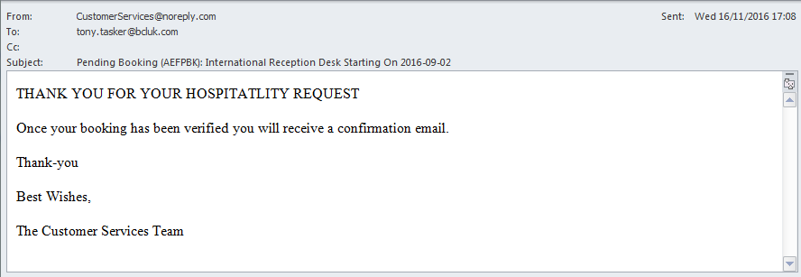
Figure 1 – Provisional Booking AutoEMail

Provisional Booking Email – AEFFFC – Enabled=I:1;U:0;D:0
No | Test | Tester | Pass | Notes
1 | In CABS locate a function to test with:  SELECT * FROM FUNC_FIL WHERE F_STARTDATETIME < GETDATE() AND F_STATUS = 'CONFRM' ORDER BY F_STARTDATETIME DESC  Using F118805 | TT
2 | Change the status of the Function to Confirmed  UPDATE FUNC_FIL SET F_STATUS = 'CONFRM' WHERE F_REF = 'F117805'  Check status of AutoEmail Queue  SELECT * FROM vw_AEFLINK WHERE AEFL_FREF = 'F117805' | TT |  | For Email Template AEFFFC:  AEFL_CanSend should be 1,  AEFL_Sent should be 0,  SessionSendable should be 1,  Sendable should be 1,  MatchCriteria should be 1
3 | Process the AutoEmail  EXEC CABS_AUTO_EMAIL_FUNCS_SESS_CHECK | TT |  | Email delivered as per Figure 2

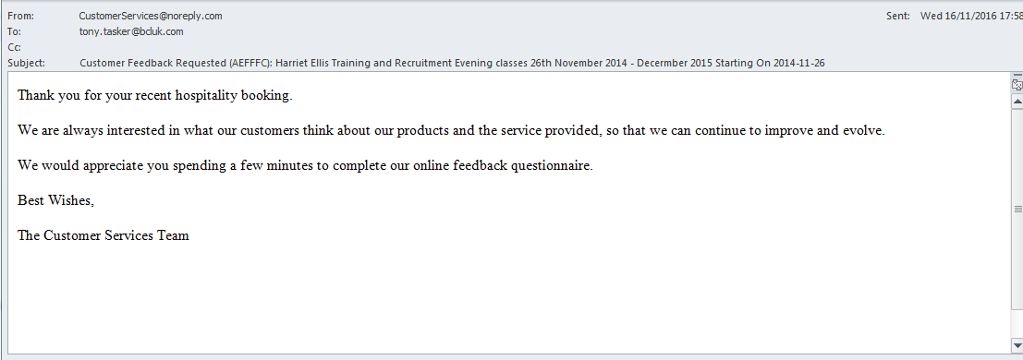
Figure 2 – Feedback From Customer Request AutoEMail

Provisional Booking Email – AEFFFC – Enabled=I:1;U:0;D:0 – Added Extra
No | Test | Tester | Pass | Notes
1 | Using CABS Console added an Extra to F117805 | TT
2 | Check status of AutoEmail Queue  SELECT * FROM vw_AEFLINK WHERE AEFL_FREF = 'F117805' | TT |  | For Email Template AEFFFC:  AEFL_CanSend should be 1,  AEFL_Sent should be 0,  SessionSendable should be 1,  Sendable should be 1,  MatchCriteria should be 1
3 | Process the AutoEmail  EXEC CABS_AUTO_EMAIL_FUNCS_SESS_CHECK | TT | x | Email delivered as per Figure 3  This should not have been sent. The issue is that the enabled key in the template section is used for both FUNC_FIL and AI_FILE – so this email will get sent when a record is inserted into FUNC_FIL or AI_FILE.

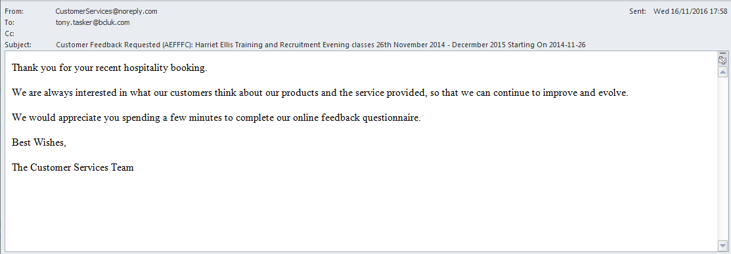
Figure 3 – Feedback From Customer Request AutoEMail

